Artificial Intelligence CS-GY 6613 Project 1

**Required Packages:**

* Numpy (used for random state generation, this function is not used unless no initial state is provided)

**Instructions for Running Code:**

To run this 8-Puzzle Solver script, you must provide two required arguments: the path to the root_folder containing the data, and the specific input file to process using the -i or --input flag (e.g., -i input1.txt). You can optionally specify the heuristic function with the -he flag, choosing between manhattan or linear_conflict (which is the default). Additionally, you can define a name for the output file with the -o flag, although the heuristic utilized should not be included in the output file name. Additionally, to enable more detailed console output by simply including the -v or --verbose flag in your command.

Example:

* python .\src\solve.py ./tests -i test1.txt -o output1  
  python <location of script> <root folder> -i <file name> -o <output file name>

# Output Solutions:

**Solutions:**

*Output1h1.txt*

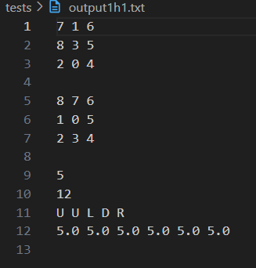

*Output1h2.txt*

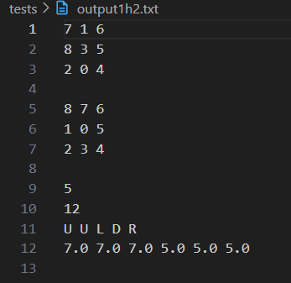

*Output2h1.txt*

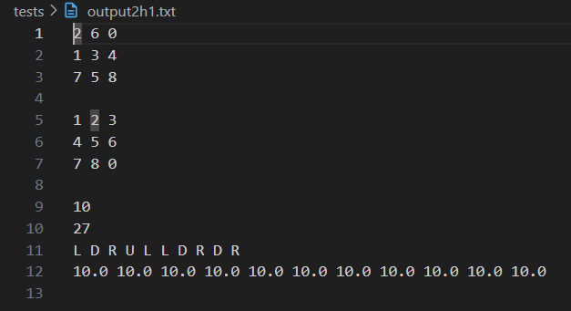

*Output2h2.txt*

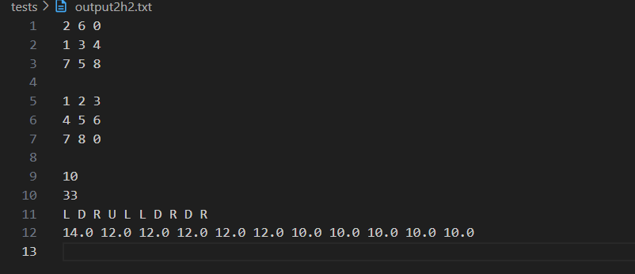

*Output3h1.txt*

*Output3h2.txt*

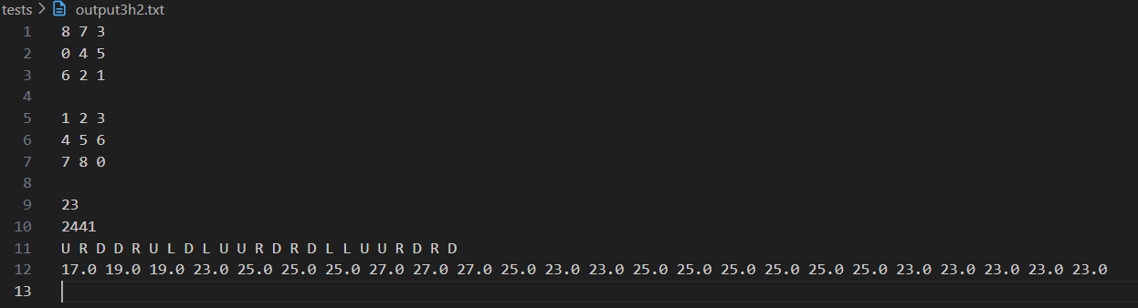

# Source Code (attached pdfs after this page):

Source Code on GitHub: <https://github.com/DiegoRos/8-Puzzle-Game>